To all Giggles families,

We would like to thank you again for supporting us here at Giggles and allowing us to be a part of your children’s lives.  It is an honor and responsibility that we don’t take lightly! The health, safety and wellbeing of your children is always our first priority. As such, we continuously evaluate the needs of our families, children, staff, and community to determine our policies and keep things running smoothly. You will find attached the official Giggles Playcare 2022 Policies and Procedures, as well as our facility rules for the kids.  Not a great deal has changed from last year’s document; there are a few points that have been adjusted for clarity, our health screening policy has relaxed slightly, some points have been elaborated on to help families understand what to expect when utilizing our services. We have added our infant program information and have adjusted a couple of things to allow for having babies with us again. There are also some internal adjustments with Ms Leesa no longer being as active in the daycare operations and Ms Kristi’s move into management.

Please, look over the entire packet and refresh or familiarize yourself (and anyone else that will be picking up or dropping off) with the information. The last page is for you to sign and return to the office for our records; the packet is yours to keep for your records and refer to if you have any questions. It really helps everyone at Giggles to be able to do the best by every child when staff, parents and children all are on the same page and know what to expect from each other.

Thank you for your understanding and cooperation!

**Operational Policies and Procedures**

**For Giggles Drop-in Playcare**

**2022**

**406-897-5050**

**gigglesplaycare@gmail.com**

**734 9th Ave W**

**Unit 8**

**Columbia Falls, MT 59912**

**Giggles Playcare Hours of Operation**

     Monday-Friday ~ 7:30am-6:00pm

Saturday & Sunday ~ Closed

**Giggles Playcare Daily Schedule\***

7:30 - Open

8:30 - Morning Snack

10:00 - Morning craft/activity

11:30 - Lunch

12:30-2:30 - Quiet/NapTime

3:30 - Afternoon Snack

6:00 - Closing time (if all kids leave earlier in the day, we will close up anytime after 4:30)

*\*Schedule subject to change/adjust as needed*

**Illness Exclusion**

For the health and physical well-being of each child at Giggles Playcare, we will strictly adhere to the following illness exclusion criteria:

* Fever of temperature of 100 degrees Fahrenheit or higher
* Vomiting
* Constant cough
* Swelling/Redness of the throat
* Extreme fatigue/out of character lethargy
* Red/draining/crusty eyes
* Head Lice
* Skin Rash
* Bumps on hands, feet and/or throat
* Uncontrollable diarrhea
* Mouth sores
* Diagnosis of a communicable disease
* If a child is suspected of having a contagious condition, a parent or authorized pick-up person must arrive ***as soon as possible***, not to exceed one hour after initial call.
* A child must be fever and symptom free, without use of medication, for a full **24 hour** period before they are allowed to return to Giggles.
* If a child is diagnosed with a contagious condition, please, notify Giggle Playcare as soon as possible so we can alert other families that will be affected. **Strict confidentiality will be upheld in every case!**

***Giggles Playcare* 2022 Policies and Procedures**

This “Policies and Procedures” document is yours to keep as a reference. We do ask that you sign the last page and hand it in at the office, stating that you have read, understand and agree to the conditions outlined in the following pages.

***Registration***

* Giggles Playcare is a first-come/first-served drop-off child care facility for all children ages 2 months to 7 years old. Our facility set up & routine is geared more for the younger children. However, we know that sometimes things come up and we want to be there for our families, so if a child is 8-10 and has younger siblings that come regularly, they are welcome at Giggles if short term care is needed on an occasional basis.
* Before your child(ren)’s first visit to Giggles, a parent or legal guardian must fill out our Admission Form in its entirety. It is available on our website, or a paper copy can be picked up at the office.
* All children must be up to date on vaccinations, and we need to have a copy of their records for our files. If a child is exempt from immunizations for any reason, we must have a notarized exemption form and a health statement from the child’s primary health care professional.
* If desired before your first visit, parents/guardians can be provided with a tour of the center by the staff. We do encourage you to call and make an appointment to see the facility after our last child has left for the day. The staff member who is closing that evening will let you know if it works to get a tour that day and set a time.

***Drop-Off and Pick Up***

* Giggles staff reserves the right to refuse admittance at any time to any child or family at our sole discretion.
* Before dropping your child off at Giggles, please be confident that your child is in good health and has not been recently exposed to a known illness. If a staff member suspects a child is ill, a wellness check may be conducted before the child is admitted into care.
* At drop off, we require that the child(ren) and any items that they bring into the facility must be reasonably clean and sanitary.
* We **DO NOT** **allow parents in the playroom** at any point in the day.
  + You are welcome in the locker area to assist your child. We ask that when multiple families are picking up or dropping off at the same time, please allow the family that is in the locker area to finish up before entering with your child(ren).
* During peak drop-off/pick-up times we appreciate your patience, and ask that you allow us to get kids checked in & out on a first-come/first-served basis.
* At drop off, please, put a name tag on your child’s locker. When a child’s locker does not have a name tag, it makes it difficult for Giggles staff to do our job efficiently. The name tags are magnetic and located on the whiteboard by the gate into the locker area. If your child is a regular visitor to Giggles, they will have a permanent one with their name on it; if they come more sporadically or have just started attending, there are blank ones and a dry erase marker to write their name.  At pick up time the magnet goes back on the board so the staff can wipe down the lockers.
  + The kids are welcome to take their own magnets on and off their lockers, but we ask that you not allow them to move around or play with the other magnets on the board. Children are not allowed to get into other people’s lockers or remove name tags from other people's lockers. Please, monitor your child(ren) while they are in the locker area at pick-up and drop-off.
* When you give us your pick-up time for the day, **do your best to arrive by that time** and if something unavoidable comes up, **please, CALL** to let us know that it will be later.  If someone is going to be picking up other than the person who dropped off, make sure you are able to tell us when that person should arrive. We plan the daily schedule and make staffing decisions based on when children are set to be picked up.
  + Always make sure that you pick up your child ***before* we close**.  If your child is still at the facility at closing time, we will begin calling the contacts on the account.  At 5 minutes past closing, a charge of $1 per child per minute past close will be added to your account.
  + If your child is not picked up within an hour after closing and we cannot get a hold of anyone, we will contact the Columbia Falls Police Department.
  + It is absolutely imperative that your account is always current with **accurate phone numbers, emergency contacts, email and mailing addresses.**
* Giggles staff WILL NOT release your child to anyone who is not on the authorized pickup list on your account. If it is the first time that they have picked up your child, please, make sure they have their ID present to show the staff member working at that time.
* From time to time, important notices and information will be posted on the door, windows and in the locker area.  Also, be sure to check your child’s locker for artwork or notes from the staff.

***Payment***

* **Payment in full** is required at pick up - we do not carry balances on any account.
  + We cannot accept checks.
  + Calling in a credit card payment is something we avoid because the credit card system charges us a significantly higher fee to manually enter a card than to swipe that same card in person.
  + We offer 10% off for all prepay amounts over $100. We also give our military families a 10% discount. Proof of service is required to receive a military discount.  Military discount and prepaid discount cannot be combined. The sibling discount is 20% off of each additional child on the same account and does apply in addition to other discounts.

***Medication***

* Giggles staff will administer medication/ointment from its ORIGINAL CONTAINER with prior, written authorization. Medication forms will be filled out with each dose/application information. We will not administer medication in excess of the medication’s dosage instructions or directions of the child’s medical professional.
  + Parent authorization is not required to administer a medication to a child in a medical emergency to prevent the death or serious bodily harm of the child in our care, provided that Giggles staff administers the medication as prescribed, directed and intended.
  + All medication will be stored safely, appropriately and out of reach of children.

***Behavior, Guidance & Discipline***

* Violence (including in play), physical or verbal bullying, rude or sexually inappropriate behavior **WILL NOT BE TOLERATED**
  + Children hitting, kicking, biting, punching, scratching, spitting, throwing things or using language that is mean, foul, disrespectful or inappropriate towards the staff or other children is unacceptable.
* In our facility we praise positive actions, and instruct & remind the children how to effectively use appropriate behavior, proper manners and to play safely. In the event that positive reinforcement and reminders are not effective, we do use timeouts as an incentive to correct unacceptable behavior.  A “Time Out Report” will be filled out and put in/on the child’s locker.
* Above the lockers there is a “Naughty or Nice” board that we use to help the children 2 years old and above visualize their actions. Children’s names are written on a magnet at drop-off; each child starts in the middle of the board and moves up with kind, helpful, polite behavior or down due to unacceptable behavior.
* Teachers at Giggles will always do our best to work with every child to ensure they have a comfortable and enjoyable time while they are in our care. It is perfectly normal and natural for a young child to have some degree of separation anxiety at drop-off. Usually, a child settles in before their guardian is even out of the parking lot, especially after a few visits. In the event that a child cannot be comforted, distracted or engaged in some activity after a reasonable amount of time, parents or guardians will be contacted to come pick up the child.  If a child is very young and/or unaccustomed to being away from their own environment, we are happy to work with the family to get them adjusted & comfortable, so that they are able to be in care without undue stress. If you are concerned about how your child will react to being left at daycare, please reach out to the management and together we will work up a plan to move forward.

***Food & Drink***

* We serve lunch and two snacks during the day; the children eat all together at the tables/high chairs. Snacks are included in the cost of care. You may send a packed lunch for your child or order our meal for an additional $4 charge. If you choose to send a lunch, we ask that it be easily served (not requiring cooking or assembling), and not overly messy. Giggles provided lunches always include protein, grain, fruit and/or vegetable. Children are not allowed to have food out or eat in the facility except for the scheduled times.
  + All food and drinks are stored, prepared and served under safe and sanitary conditions.
  + Water is available all through the day. Children may bring water bottles from home or we will provide them with one to use while they are with us.
* Parents of children with serious **food allergies** are required to provide written documentation of the allergy.  If your child is allergic to nuts, gluten, dairy or other common ingredient, it is recommended that you provide food for them as our kitchen and menu items are not guaranteed to be free from traces of these products.
* We prefer not to serve treats except for holidays & birthdays and then we give all the children the same thing (with the exception of those with special dietary needs).  Any candy, pastries or confections sent with a child will most likely be sent back home with them.
* We **DO NOT** allow children of any age to have gum in the facility for many reasons.

***Infants***

* We are thrilled to welcome babies back into Giggles this year! Our infant program will be a little different than it was, since we do not have a separate space for them anymore. We will not be able to have as many in the facility at a time, so we do recommend setting up a bit of a schedule and/or calling in to check availability. Depending on the ages and care requirements of each infant and how many other children are on premises, we are currently able to look after 2-5 at a time. As need increases, we are prepared to look into hiring additional staff.
  + To be eligible for infant care, the baby must be 2+ months old and be willing & able to accept a bottle; sufficient formula or preferred milk must be provided for the amount of time the child will be in the facility.
  + As we do not have a staff member solely dedicated to the infant program at this time, any little one that we have at Giggles must be able to be independently entertained and be allowed to self soothe. We cannot afford a staff member to be required to hold or solely focus on a single child of any age for long periods of time.
  + Parents of infants at Giggles must be able to be reached on the phone at all times while the baby is in our care.

***Other***

* We do allow children to bring toys and electronics from home but if any item causes an issue, we will remove it from the play area and put it away in the child’s locker.
  + We do ask that children not bring toys or games with numerous or small pieces.
  + Chapstick, lip balm or other treatments, and any make-up items must be kept in the locker. Money must also be kept in their locker.
  + Any item that the teachers deem dangerous, inappropriate or potentially problematic for any reason, will not be allowed into the playroom.
  + We are not responsible for your children’s electronics or toys if they get lost or broken while they are in the facility.
* If your child is in diapers or pull-ups, please, make sure to bring plenty of changes for the amount of time the child will be here. We do have some extra diapers on hand and if a child uses more than provided for the day, we will add a $1 charge to your account per diaper that we provide.
  + Also, if your child is potty training or recently in underwear, please send plenty of fresh clothes.
* Accidents can happen to anyone at any time, so at least one change of clothes is recommended for every child in our care. We do have a small selection of spare clothes available. If a child needs to use an article of our clothing, a $10 per item charge will be added to your daily total, which will be refunded upon the return of the clean item to Giggles.

**Exclusion**

The exclusion of a child from care is determined by

* Whether or not the child can participate in the activities and daily schedule of the facility.
* Whether or not the child requires more care than the staff can provide, without compromising the care needs for other children in the facility.
* Whether keeping the child in care will pose an increased risk to the other children and/or staff in the facility.

**Giggles Playcare reserves the right to exclude any family and/or child from the facility based on our sole discretion.**

This policies and procedures document is in no way to be considered an exhaustive list of every possible situation or a full explanation of our daily routine.  Giggles reserves the right to make exceptions as needed on a case-by-case basis.

If you have any questions or concerns, please, feel free to talk them over with

the manager of Giggles Playcare, Ms Kristi.

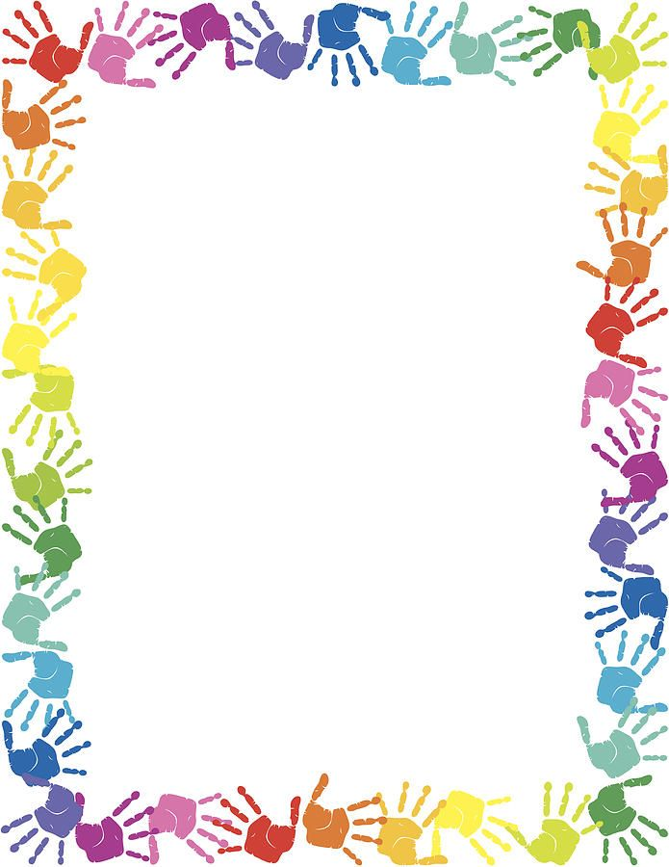**Rules for a safe, fun time**

**at Giggles**

**We do not use mean, rude or bad words…**

**only say kind, true, polite and appropriate things.**

**We keep our hands & feet to ourselves,**

**unless you are using them to be nice & helpful.**

**We take turns & share all toys, play equipment**

**and craft supplies…**

**we *do not* share cups, food or clothes.**

**Only food and drinks go in our mouths…**

**NEVER toys, craft supplies or body parts.**

**We always stay at the table or in a highchair while we eat.**

**We use our walking feet in the building, watch where**

**we are going and always be careful of our friends.**

**We use our inside voices, and don’t shout or yell.**

**We always use the climbing ramp to get into the playset…**

**the slide is for going down on our bottoms.**

**We use our manners when we need something**

**and wait patiently until we get it.**

**The bathroom is not a place to play… we go in one at a time,**

**do what we need to do, wash our hands and come out.**

**If you need help, call for a teacher!**

**Children 2 years and older do not go into the baby area.**

I, __________________________________ have read, understand and agree to all of the updated policies and procedures that Giggles Playcare has provided above.

By signing, I acknowledge that I understand that the policies and procedures above are in place so that my child and all other children in attendance can get the care and attention they need while at Giggles Playcare. I also state that if I have any questions or concerns about something, I have the opportunity to voice my opinion to the management.

____________________________________________________________

____________________________________________________________

____________________________________________________________

Child(ren) name(s)

_________________________________________________                    _________________

Parent/Guardian signature                                                                                          Date

_________________________________________________                    _________________

Parent/Guardian signature                                                                                          Date